Objectives:

* Using the while and for loops
* **There are 5 challenge exercises, each worth 20%**

Please submit this document for grading when completed… Please work in-groups.

This lab class exercise is based on Chapter 4 Loops.

**Project #1** (using the for loop and getting the square root)

**Project #2** (using the for loop, and getting the sum of numbers)

**Challenge exercise #1:** continuing with project #2, get the average of the 5 numbers also.

**#1 print screen the output with code below here.**

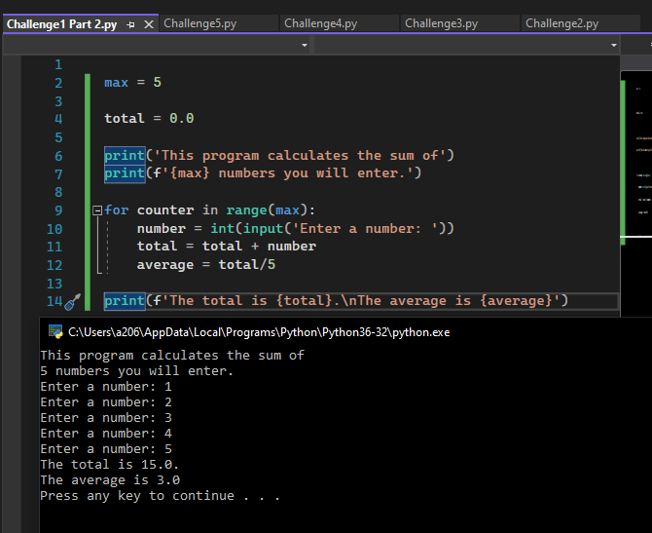

**Project #3:** Retail validation program using the while loop

Validating the entry of the wholesale cost, see blue arrow bottom.

**Project #4:** Property Taxes, using the while loop

**Challenge Exercise #2: complete the following program below:**



**#2 print screen the output with code below here.**

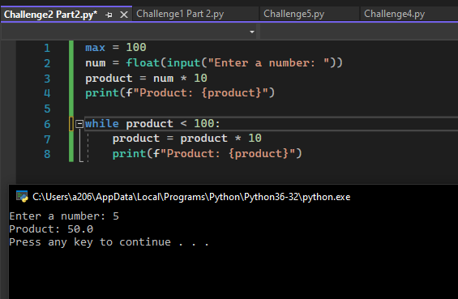

**Challenge Exercise #3: complete the following program below:**

**#3 print screen the output with code below here.**

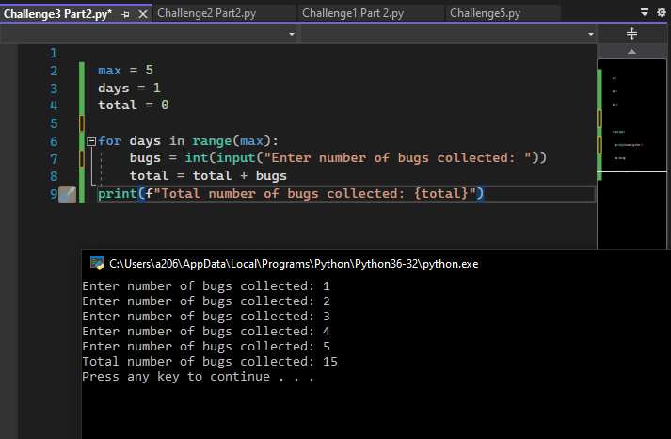

**Challenge Exercise #4: complete the following program below:**

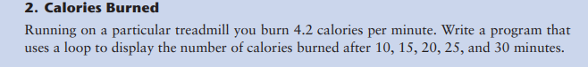

**#4 print screen the output with code below here.**

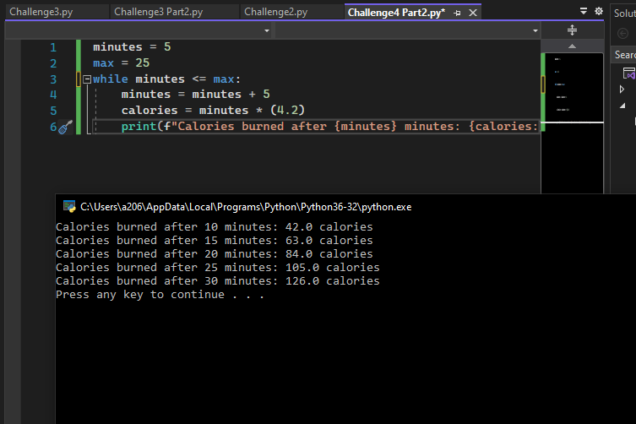

**Challenge Exercise #5: complete the following program below:**

**#5 print screen the output with code below here.**

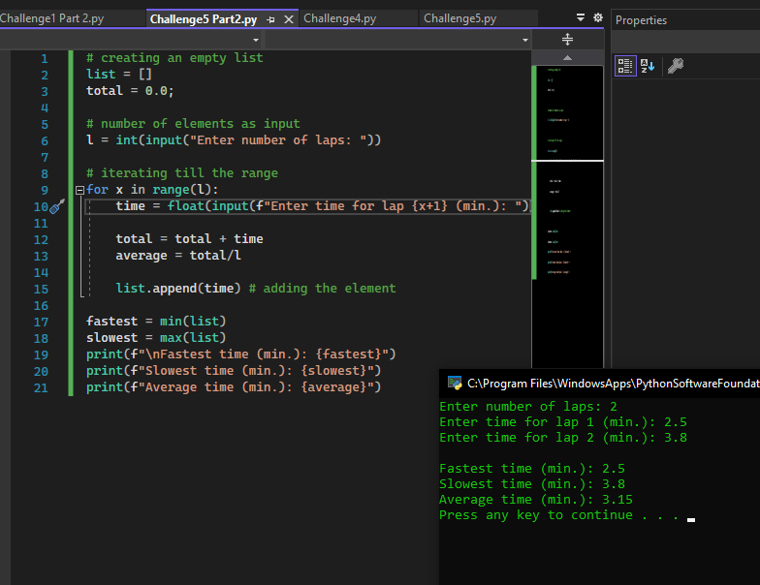

**Submit this document to module 3 class exercise.**